Process Analysis Document

Customer Churn Analysis & Retention Strategy

1. Introduction
Business Process Analysis is a structured approach used to understand how an organization currently operates and identify opportunities for improvement. In the context of customer churn management, process analysis helps evaluate existing practices for monitoring customer behavior, identifying churn risks, and implementing retention strategies.
This document presents the current-state (AS-IS) process and the future-state (TO-BE) process for customer churn management within a telecommunications organization. The objective is to identify process inefficiencies, highlight improvement opportunities, and recommend a more proactive, data-driven approach to customer retention.

2. AS-IS Process Diagram
1. Current Customer Churn Management

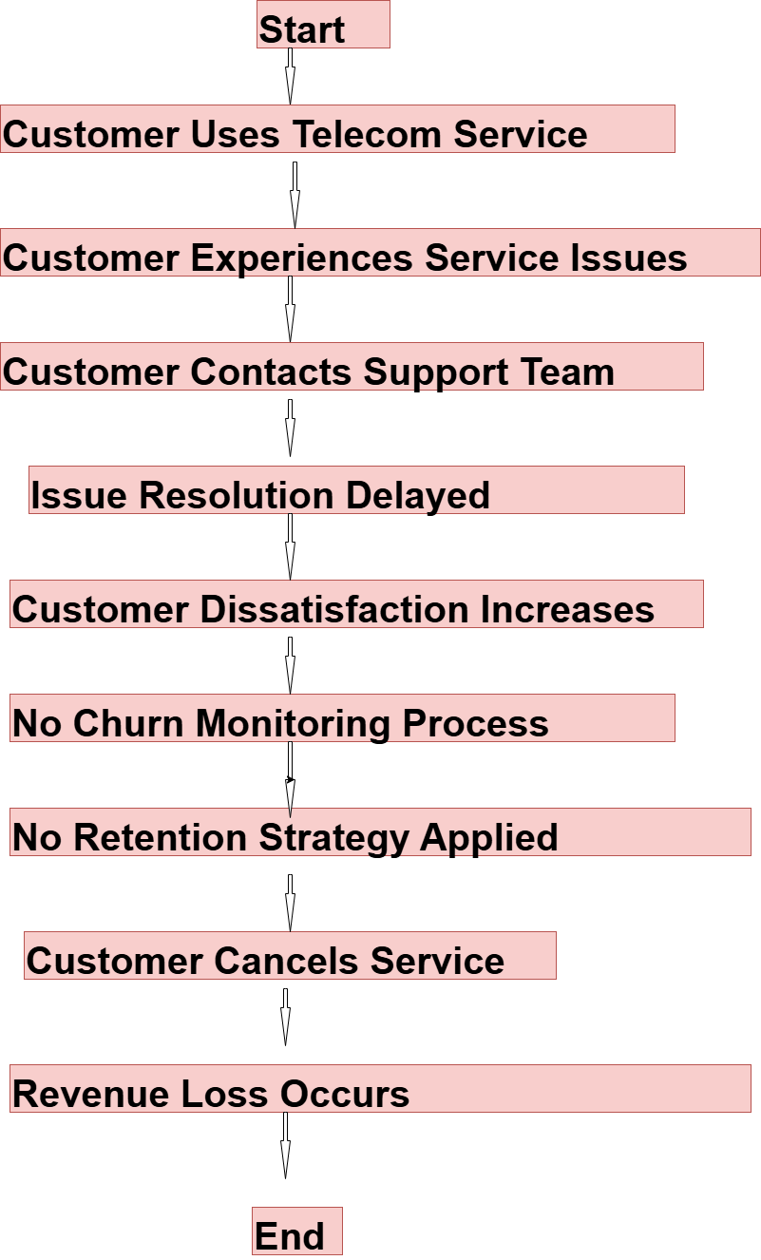
2. Decision Boxes
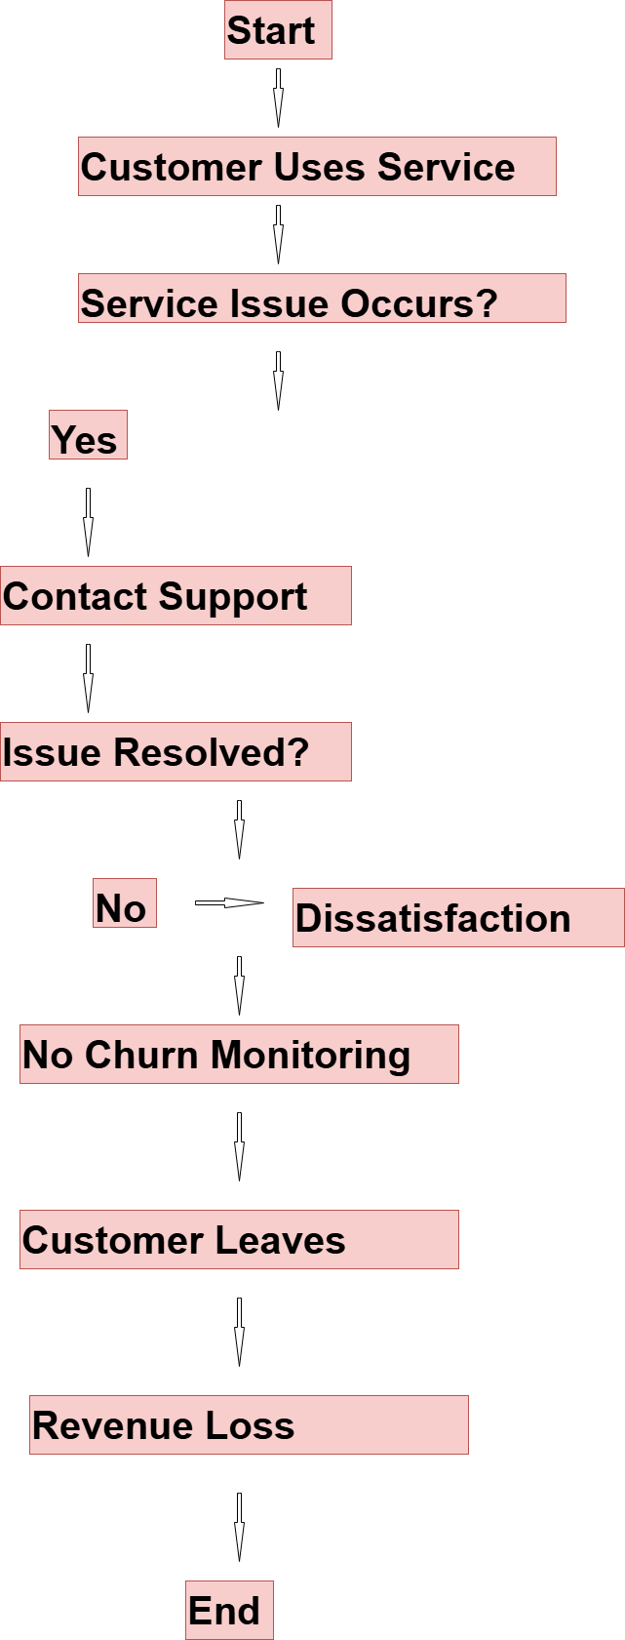
3. AS-IS Process Description
The current customer churn management process is primarily reactive in nature. Customers use telecom services and may encounter issues such as service disruptions, billing concerns, lack of technical support, or dissatisfaction with pricing plans.
When customers experience problems, they typically contact customer support. However, due to the absence of a dedicated churn monitoring mechanism, customer dissatisfaction often goes unnoticed until the customer decides to discontinue the service.
The organization currently lacks a centralized system to monitor customer behavior, identify high-risk customers, and initiate retention actions. As a result, customer attrition occurs without timely intervention, leading to revenue loss and reduced customer lifetime value.

4. AS-IS Observations
The analysis of the current process revealed several business challenges:
Observation 1: Lack of Churn Monitoring
There is no centralized system for tracking customer churn trends or monitoring customer risk levels.
Observation 2: Reactive Customer Retention
Retention efforts are initiated only after customers express dissatisfaction or cancel services.
Observation 3: Limited Customer Insights
Customer data is available but is not utilized effectively to identify behavioral patterns or churn indicators.
Observation 4: Manual Reporting Process
Business reports are generated manually, resulting in delayed decision-making and limited visibility into churn trends.
Observation 5: Revenue Loss Due to Churn
The organization lacks mechanisms to measure and analyze the financial impact of customer attrition.

5. Challenges Identified in the AS-IS Process
Challenge | Business Impact
No churn tracking system | High customer attrition
Manual reporting | Slow decision-making
No customer risk segmentation | Missed retention opportunities
Limited customer insights | Ineffective business strategies
No revenue impact analysis | Financial losses remain untracked

3. TO-BE Process Diagram
Future Customer Retention Process
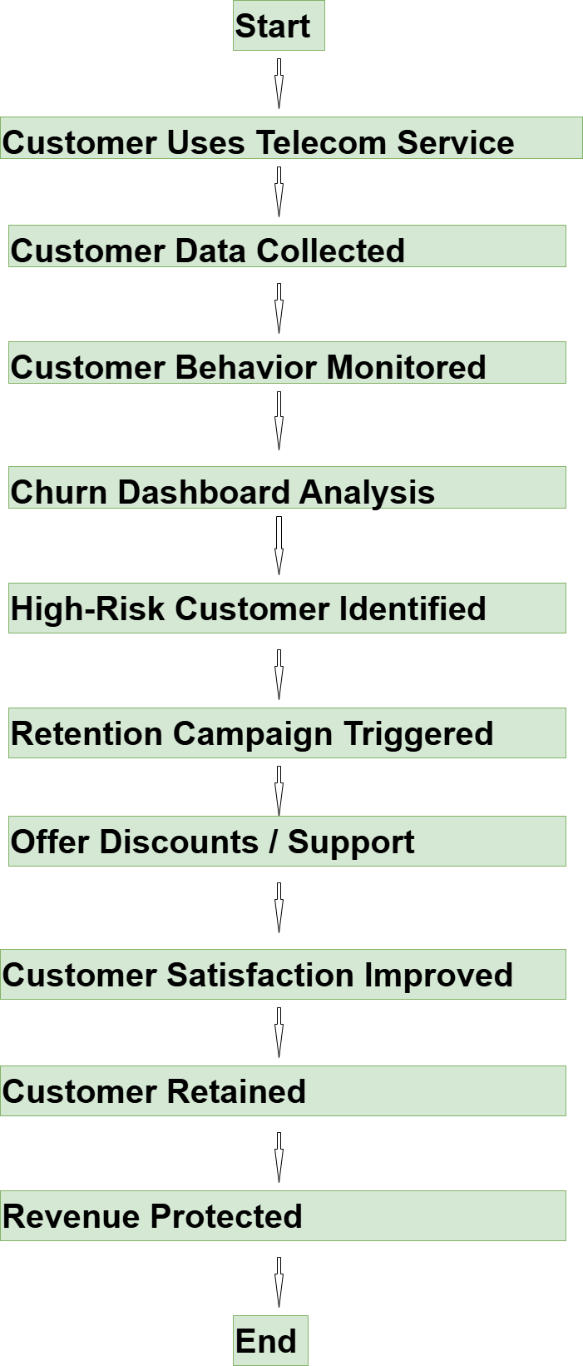

Process With Decision Nodes
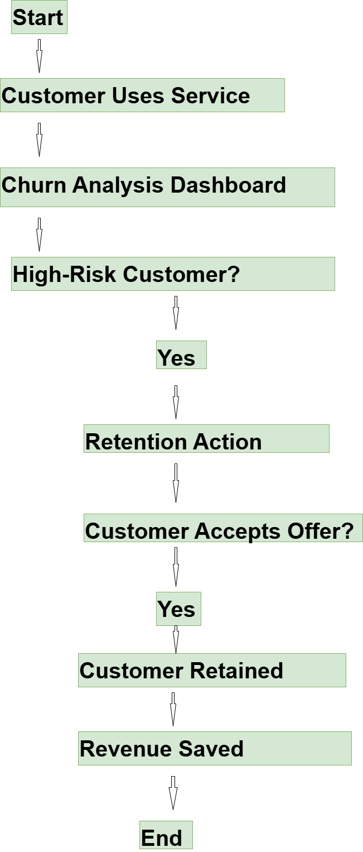

TO-BE Process Description
The proposed future-state process introduces a data-driven customer churn management framework. Customer information is collected and analyzed using SQL, Python, and Power BI to identify churn patterns and customer risk levels.
The organization will implement an interactive dashboard that continuously monitors key churn metrics and highlights customers who are likely to discontinue services. Once high-risk customers are identified, retention initiatives such as promotional offers, loyalty programs, contract upgrades, and enhanced customer support can be implemented proactively.
The future-state process enables business users to make informed decisions based on real-time insights, reducing customer churn and protecting revenue.

TO-BE Benefits
Benefit 1: Proactive Customer Retention
High-risk customers can be identified before they leave, allowing timely intervention.
Benefit 2: Improved Decision-Making
Business stakeholders gain access to interactive dashboards and actionable insights.
Benefit 3: Enhanced Customer Experience
Retention initiatives and improved support services increase customer satisfaction.
Benefit 4: Revenue Protection
Reducing customer churn helps maintain recurring revenue and customer lifetime value.
Benefit 5: Operational Efficiency
Automated reporting reduces manual effort and improves reporting accuracy.
Benefit 6: Better Customer Segmentation
Customers can be grouped based on risk levels, contract types, and service usage patterns.

9. Comparison Between AS-IS and TO-BE Processes
Area | AS-IS Process | TO-BE Process
Churn Monitoring | Not Available | Dashboard-Based Monitoring
Customer Risk Identification | Manual | Automated Analysis
Reporting | Manual Reports | Interactive Power BI Dashboards
Retention Strategy | Reactive | Proactive
Decision Making | Experience-Based | Data-Driven
Revenue Tracking | Limited | Comprehensive Revenue Analysis
Customer Insights | Minimal | Advanced Customer Segmentation

10.Process Improvement Summary
The analysis indicates that the current customer churn management process lacks proactive monitoring, customer risk identification, and analytical reporting capabilities. These limitations contribute to increased customer attrition and revenue loss.
The proposed future-state process introduces a comprehensive churn analytics framework that enables early identification of high-risk customers, automated reporting, customer segmentation, and proactive retention strategies. By leveraging data analytics and business intelligence tools, the organization can improve customer retention, reduce revenue leakage, and support strategic decision-making.
The implementation of the proposed process is expected to enhance operational efficiency, improve customer satisfaction, and establish a strong foundation for future predictive analytics initiatives.

11. Conclusion
The transition from the current-state process to the proposed future-state process represents a significant improvement in the organization's ability to manage customer churn. Through the adoption of data-driven analytics and proactive retention strategies, the business can gain greater visibility into customer behavior, improve retention rates, and achieve sustainable business growth.

